Provide a screenshot to show that you successfully installed DASK.

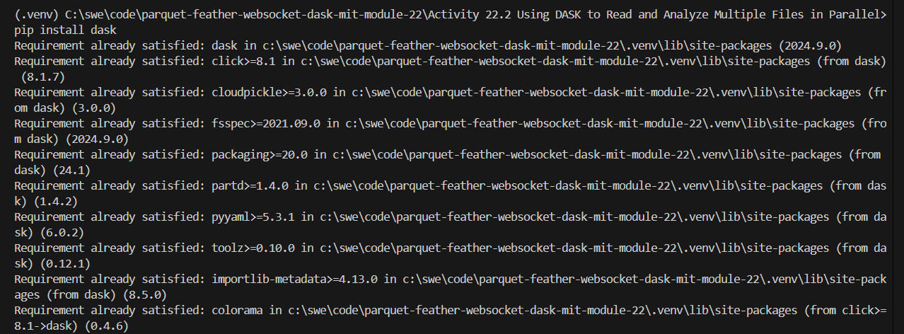

Provide a screenshot to show that you successfully ran the dask-scheduler.

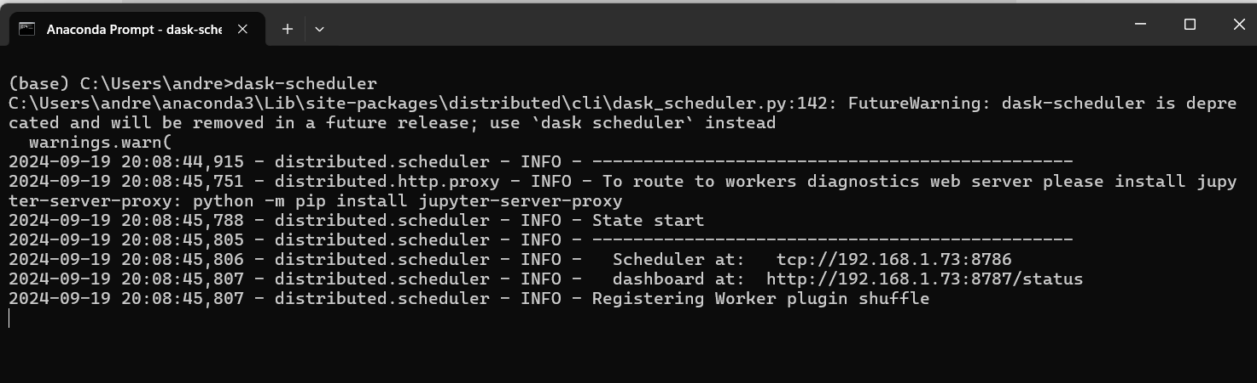

Provide two screenshots to show that you successfully started both of the dask-worker processes by passing the correct address to the dask-scheduler.

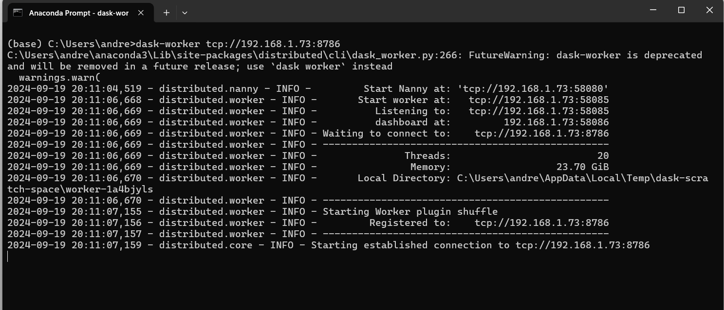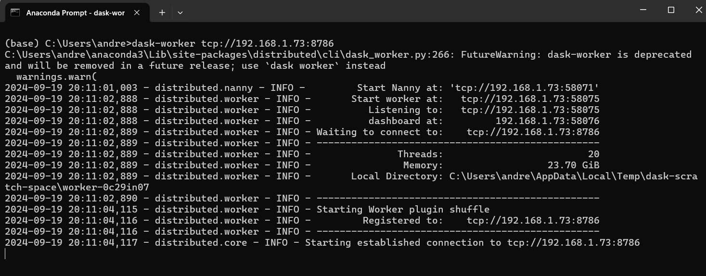

Provide a screenshot to show that you created a Jupyter Notebook and successfully imported the DASK libraries.

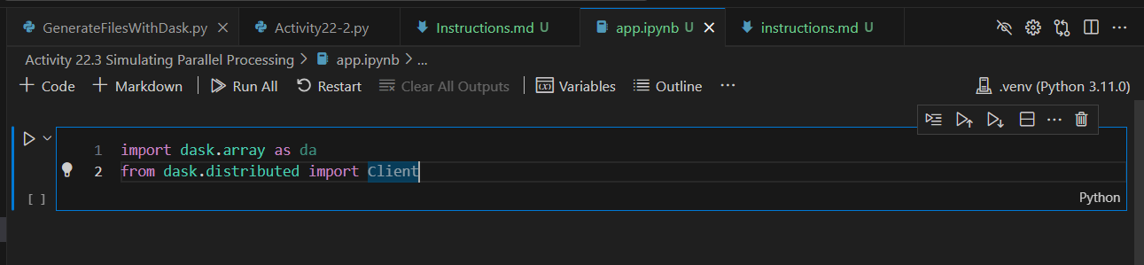

Provide a screenshot to show that you successfully executed the command to create a matrix, compute the mean, and assign the value to the y variable.

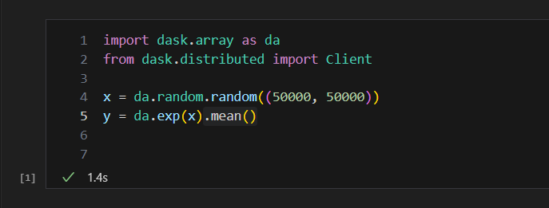

Provide a screenshot to show that you successfully computed your calculations using DASK using the compute function.

